Project 14-1: Create a memory calculator
For this project, you’ll create a form that lets the user perform the functions provided by a memory calculator. This project builds on the calculator described in project 12-1. If you have already done project 12-1, you can modify it so it works as described here.
The design of the Calculator form
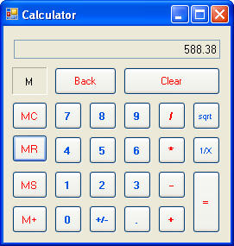
Operation
- To clear the contents of memory, the user clicks the MC button. To save the value that’s currently displayed in memory, the user clicks the MS button. To recall the value that’s currently in memory and display it in the calculator, the user clicks the MR button. And to add the value that’s currently displayed to the value in memory, the user clicks the M+ button.
- An M is displayed in the box above the MC button whenever the memory contains a value.
- See project 12-1 for additional details.
Specifications
- Create a class named MemoryCalculator that inherits the Calculator class described in project 12-1. The MemoryCalculator class should add properties and methods as needed to implement the memory function.
Note:
- MemoryCalculator class design:
Method Description
MemoryStore Stores the calculator’s current value in memory.
MemoryRecall Sets the calculator’s current value to the value stored in memory.
MemoryAdd Adds the calculator’s current value to the value currently stored in memory.
MemoryClear Clears the current memory value.

